Notes on Preparing the List of Successful & Reserve DP Applicants
A. Prerequisites
- Upgrade WebSAMS to version 2.0.1.01122011 or above.
- Users are granted the access rights to the functions of SOA.
- Schools have received SOR571P2D1S - SOA DP APPLICANT (DATA) in CDS.

B. Steps for preparing the List of Successful & Reserve DP Applicants in WebSAMS
- Log on [WebSAMS]
- Click [CDS]>[Incoming Message], select & decrypt the message SOR571P2D1S - SOA DP APPLICANT (DATA).
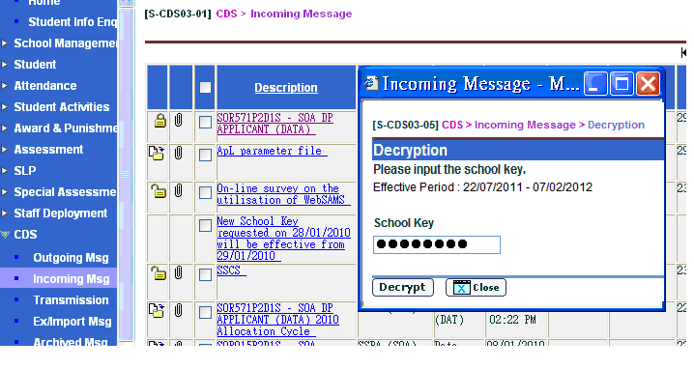
- Click[SPA]>[SOA]>[Data Communication], then import the message SOR571P2D1S - SOA DP APPLICANT (DATA).
- Click[SOA]> [Report], select DP Applicant List (R-SPA002-E) to check & print the data.
Users should contact their respective Liaison Officers of the SPA Section if there is any incorrect school or DP Applicant information.

- Click[SOA]>[Selection of DP Applicants]
For Secondary Schools Participating in the SSPA System
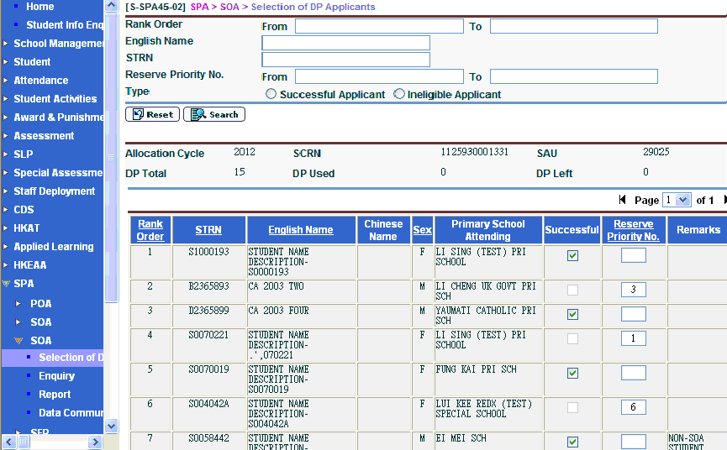
--Select DP applicants as successful by checking the box of Successful and select DP applicants as reserved by assigning Reserve Priority No.
--Click [Save] before proceeding to other pages.

For Secondary Schools Not Participating in the SSPA System
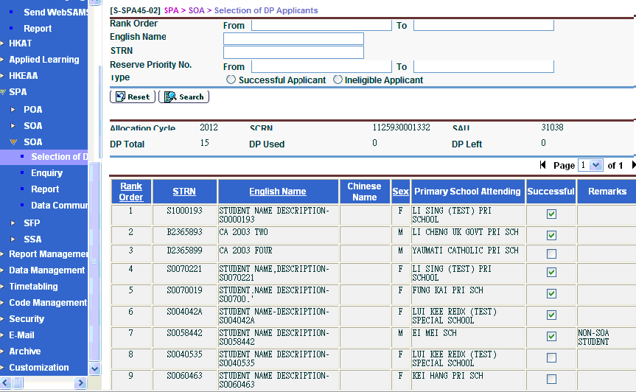

--Select DP applicants as successful by checking the box of Successful.
--Click [Save] before proceeding to other pages.
- Click [SOA]>[Data Communication]>[Prepare Outgoing Data]> [Prepare].
For Secondary Schools Participating in the SSPA System
Users might check the List of Successful & Reserve DP Applicants prepared by the system by clicking [Preview].
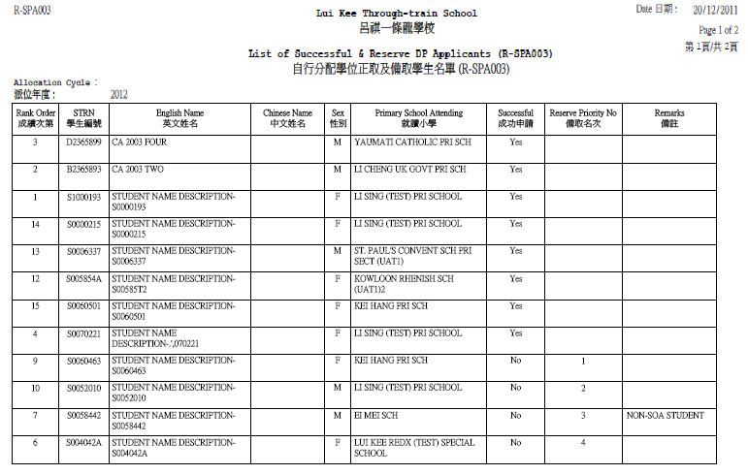

For Secondary Schools Not Participating in the SSPA System
Users might check the List of Successful DP Applicants prepared by the system by clicking [Preview].
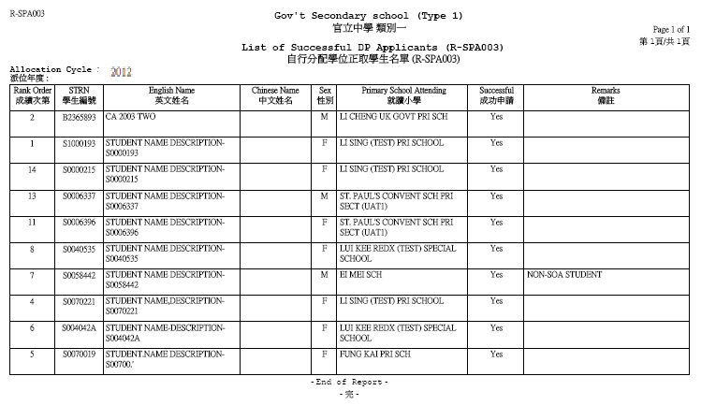
- If there is amendment, click [Un-prepare]. Then, repeat Steps 5-6.
- Click [Confirm] after checking.
- Finally, click [CDS]>[Outgoing Message], select & encrypt the message List of Successful & Reserve DP Applicants and send it to SPA Section of EDB.
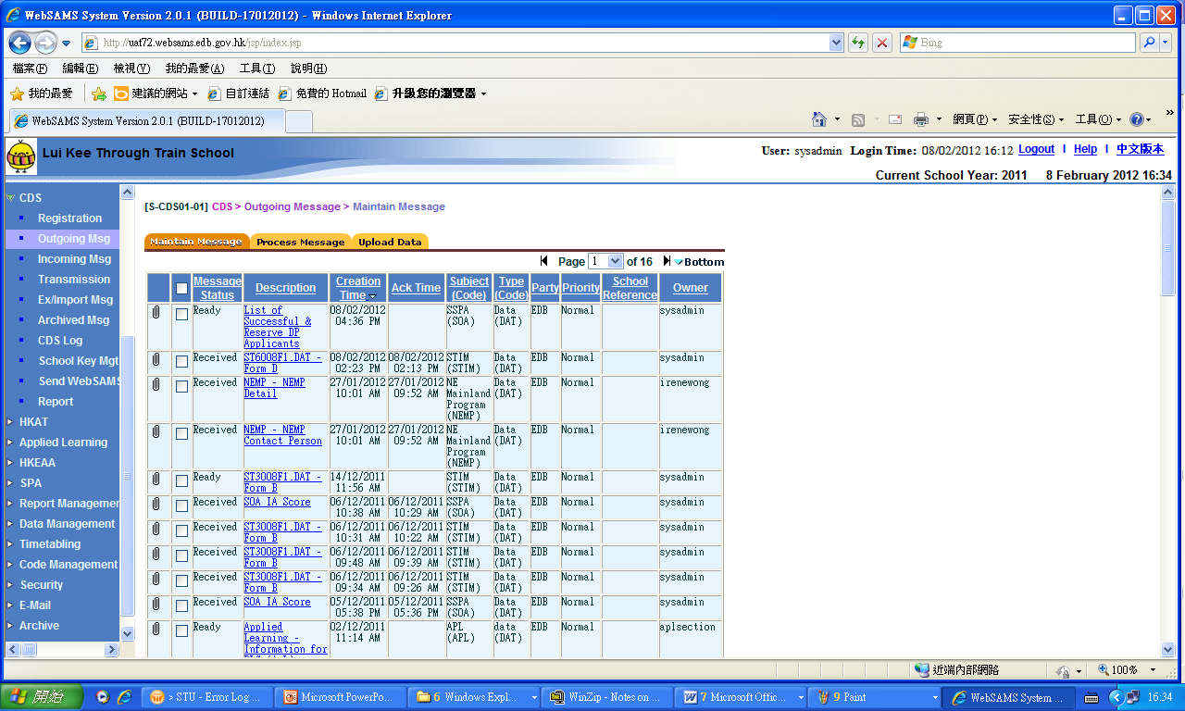
- For details of using SPA and CDS functions, please refer to the respective user manuals.

SIM Section
Education Bureau
Updated: 29-2-2012

